HAWAII RMT: INSTRUCTIONS

[FOR CONTINGENT WORKERS AND VOLUNTEERS WITHOUT NUIDs]

This year’s annual Regional Mandatory Training incorporates a nationally developed safety training program, in addition to important region-specific information (e.g., TJC accreditation, policies, and essential resources, etc.).
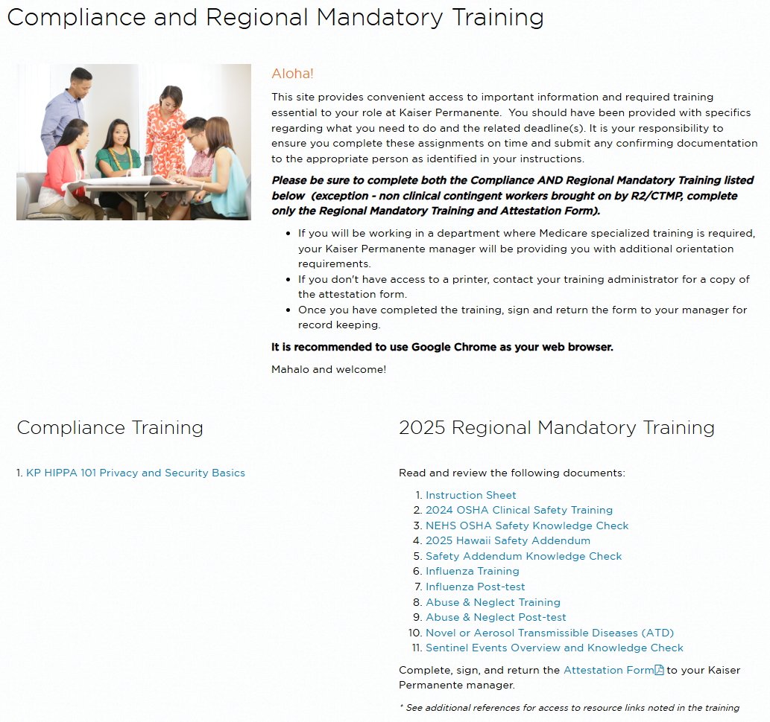
You will need to complete ALL of the items listed below to fulfill your Regional Mandatory Training requirements. Please plan for about two (2) hours to finish the training. For Hospital & Clinic Contingent Workers, those courses include:
- Introduction to OSHA Clinical Safety Training
- OSHA Clinical Package Personal Safety
- OSHA Infection Prevention and Control MOC
- OSHA Clinical package Chemical Safety
- OSHA Emergency Response
- OSHA Clinical Package Electrical-Equipment Safety
- OSHA Waste Management MOC
- OSHA Safety Knowledge Check
- Hawaii RMT Safety Addendum
- Safety Addendum Knowledge Check
- Influenza Training
- Influenza Post-test
- Abuse & Neglect Training
- Abuse & Neglect Post-test
- Novel or Existing Aerosol Transmissible Diseases (ATD)
- Sentinel Events Overview and Knowledge Check
You will not be considered complete until all the items listed above are done.
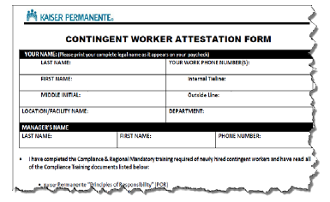

Print the contingent worker attestation form and provide the completed form to your supervisor.
Should you have questions about the instructions, contact Donna.Rictor@kp.org

