HAWAII RMT: INSTRUCTIONS

[FOR CONTINGENT WORKERS AND VOLUNTEERS WITHOUT NUIDs]

This year’s annual Regional Mandatory Training incorporates a nationally developed safety training program, in addition to important region-specific information (e.g., TJC accreditation, policies, and essential resources, etc.).
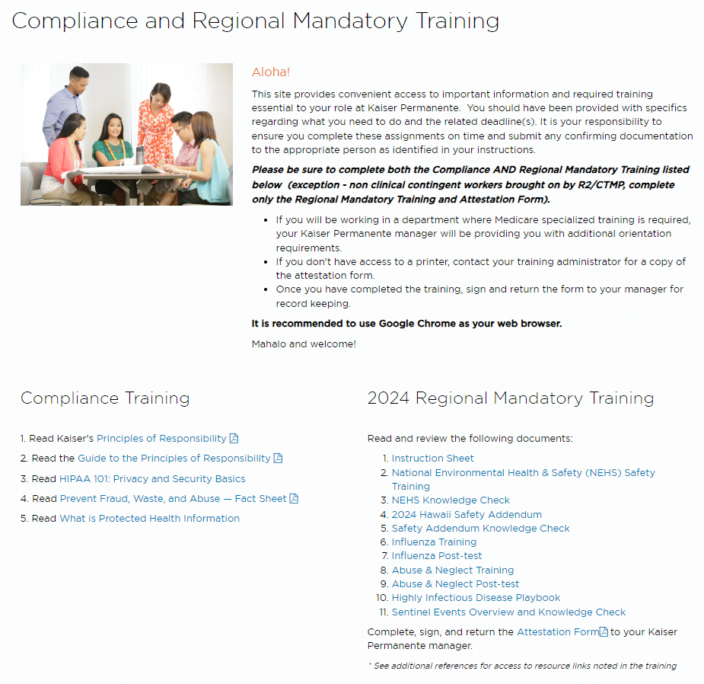
You will need to complete ALL of the listed items below to fulfill your Regional Mandatory Training requirements. Please plan for about two (2) hours to finish the training. For Hospital & Clinic Contingent Workers, those courses include:
- 2024 OSHA Clinical Safety Training
- NEHS OSHA Safety Knowledge Check
- 2024 Hawaii RMT Safety Addendum
- Safety Addendum Knowledge Check
- Influenza Training
- Influenza Post-test
- Abuse & Neglect Training
- Abuse & Neglect Post-test
- Highly Infectious Disease Playbook
- Sentinel Events Overview and Knowledge Check

You will not be considered completed
until all the items listed above are done.

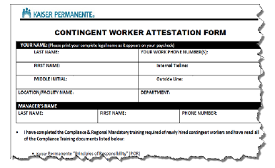

Print the contingent worker attestation form and provide the completed form to your supervisor.
Should you have questions about the instructions, contact Alyssa.A.Cadelina-Mikesell@kp.org

